DS4S Group 2 Project Plan

Problem statement:

*1) A reproduction of the Pantheon constraints shown in Fig. 18 of S18, both with and without inclusion of systematic errors.*

*2) Determine the posterior probability density of H_0 after adding a Gaussian prior on corrected supernova absolute magnitude of M =19.23 +/- 0.042. Make a figure.*

*Write your own MCMC code (do not use a publicly available code such as CosmoMC).*

*Grading is based on setup and presentation.*

*Additional stuff to maybe save for later assignment:*

*3) Tests for consistency:*

*A) A residual plot for the binned data similar to Fig. 11 of S18.*

*B) Evaluation of \chi^2 and calculation of PTE*

*C) Draw a handful of realizations from the noise covariance, and add to best-fit signal*

*D) Take the symmetric square root of the error covariance matrix. Transform the residuals r to r' = C^{-1/2}r and histogram. Compare with expectations. Note that <r' r'^T> = C^{-1/2}<r r^T> C^{-1/2} = the identity matrix. So the histogram should be consistent with a Gaussian with unit variance.*

*E) Break up binned supernova distances into several redshift ranges and test for stability of H_0 inference across these different subsets.*

Structure:

Modules are each of our first names

(parameters_adam, functionality_pritom, functionality_junying)

Desired functionalities:

Task 1)

Proposing parameter set in 3D: - Adam

Name: get_new_parameters()

Inputs: sigmas [sigma_h, sigma_m, sigma_v], previous parameters [H, omega_m, omega_v] (Optional: distribution type {gaussian etc} )

Outputs: List of 3 parameter values [H, omega_m, omega_v]

Task 2)

Compute likelihood : - Junying

Inputs: List of 3 parameter values [H, omega_m, omega_v]

Transients: least-squares errors np.lstsq(\vec{m_b}-\vec{mu})

Outputs: real number ; acceptance_probability

Task 3) - Pritom

Form Markov chain in 3D:

Task 4) -Pritom

Confirm convergence:

Task 5) - Adam

show_final_plot()

Visualization (isolate 1 variable, plot 2-d probability density) :

Presentation planning:

Deadline: May 7th

Google slides / libra

Questions need to answer:

1. Should we use D_l(z) presented in [https://iopscience.iop.org/article/10.3847/1538-4357/aab9bb/pdf#%FE%FF%00b%00m%00_%00a%00p%00j%00a%00a%00b%009%00b%00b%00e%00q%00n%003](https://iopscience.iop.org/article/10.3847/1538-4357/aab9bb/pdf#%EF%BF%BD%EF%BF%BD) P 16, or some other form? What is Ωk?
2. What other systematic errors we need to consider besides d_mb ?
3. Do we care about “Nuisance” parameter M?
4. Should we impose constraints on omega_m and omega_v ? Or we should consider them as independent ?
5. Should we also consider H0 dependent on omegas’ ?
6. Is our proposed likelihood valid or not ?
7. What are the prior distributions for the parameters ?
8. Can we adaptively change sigma_h etc, or will this violate some assumption of Markov chain applicability? (Probably no?)
9. P8 of slides: What’s the purpose of the covariance matrix? (something with error?)

Useful Resources:

[OBSERVATIONAL EVIDENCE FROM SUPERNOVAE FOR AN ACCELERATING UNIVERSE AND A COSMOLOGICAL CONSTANT](https://iopscience.iop.org/article/10.1086/300499/pdf)

[The Complete Light-curve Sample of Spectroscopically Confirmed SNe Ia from PanSTARRS1 and Cosmological Constraints from the Combined Pantheon Sample](https://iopscience.iop.org/article/10.3847/1538-4357/aab9bb/pdf#%FE%FF%00b%00m%00_%00a%00p%00j%00a%00a%00b%009%00b%00b%00e%00q%00n%003)

Random doodle space:

Discussion of navigating 3-D parameter space and relevant sigmas:

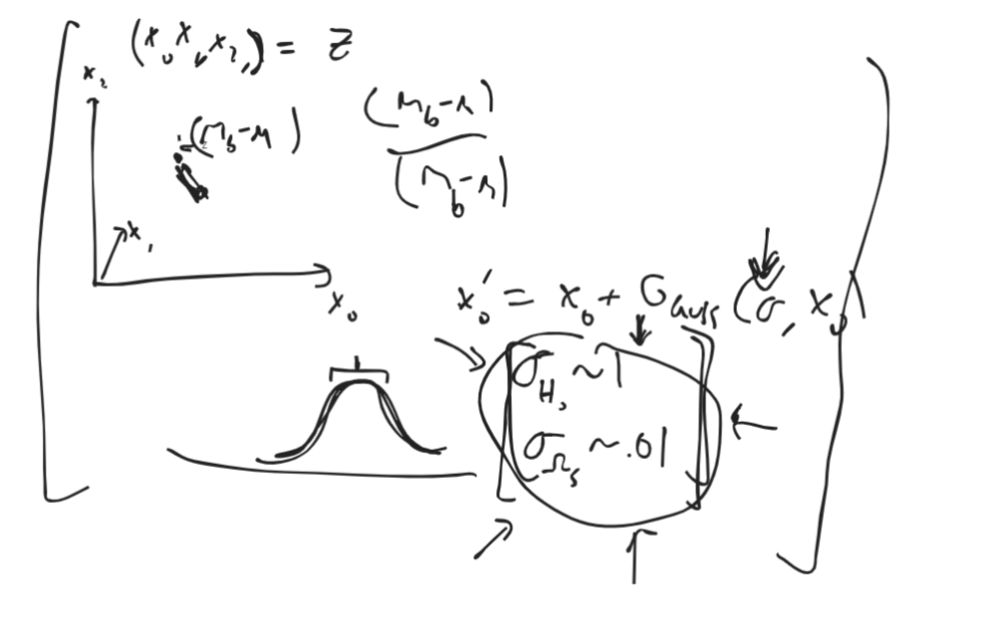

To reproduce graphic: align an ellipse with semimajor and major axes pointing to maximize data capture while minimizing least-squares distance to nearest edge? Then scale the axes to get 68% of the data etc.